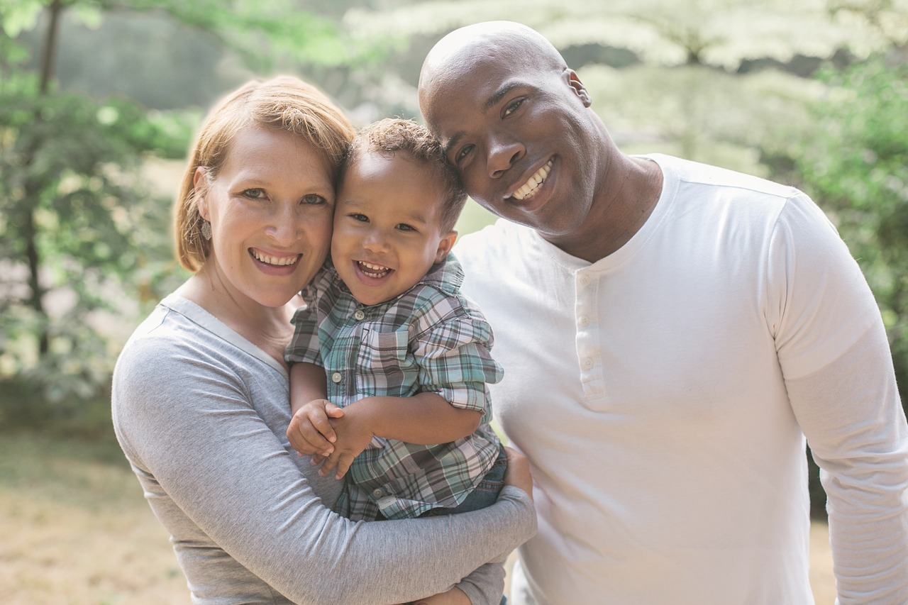
My Family
I love Daddy.
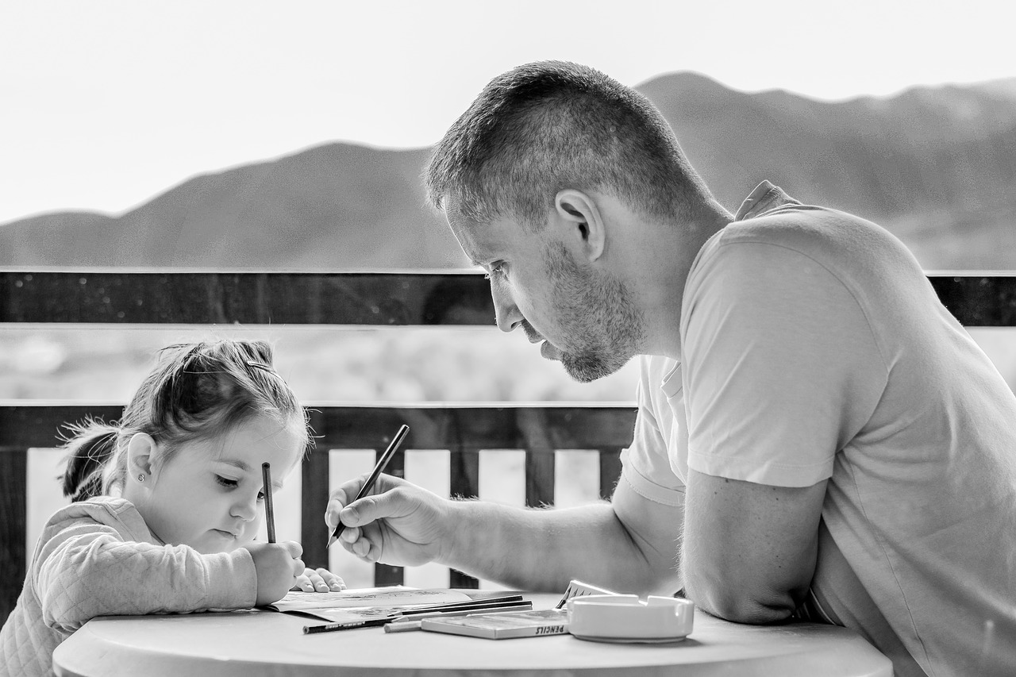
I love Daddy.
I love Mommy.
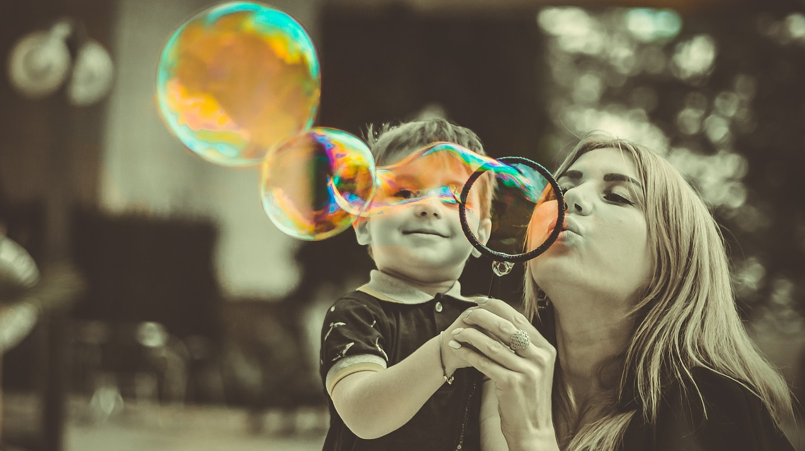
I love Mommy.
I love Baby.
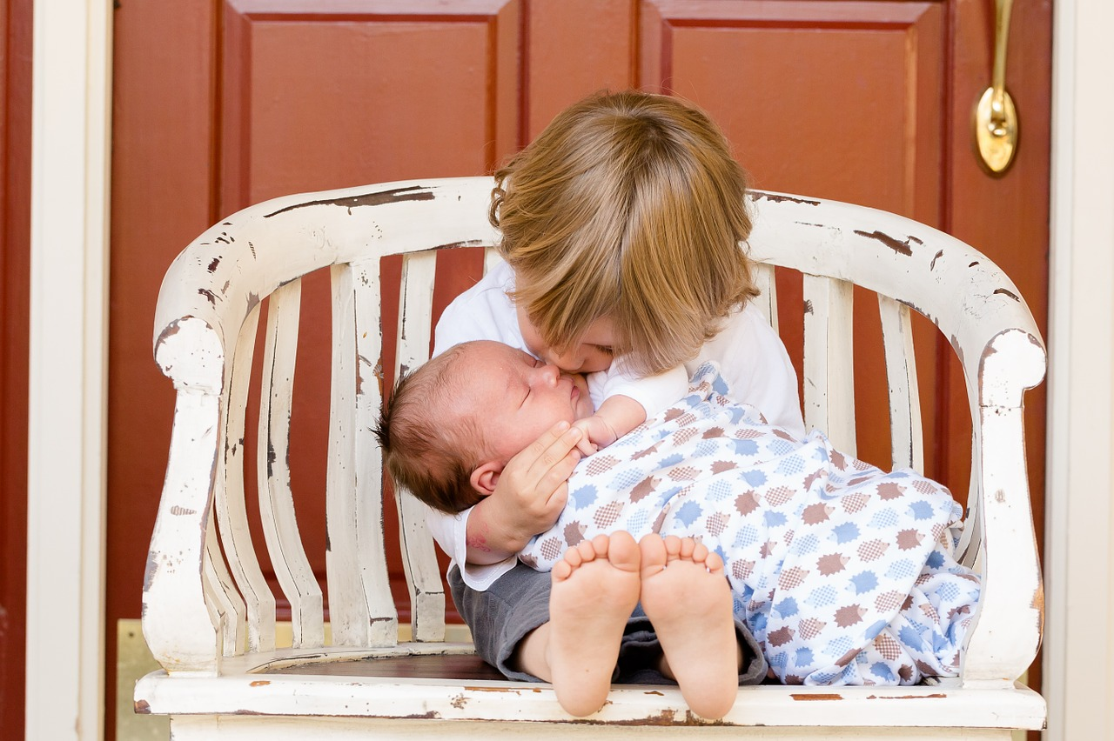
I love Baby.
I love Brother.
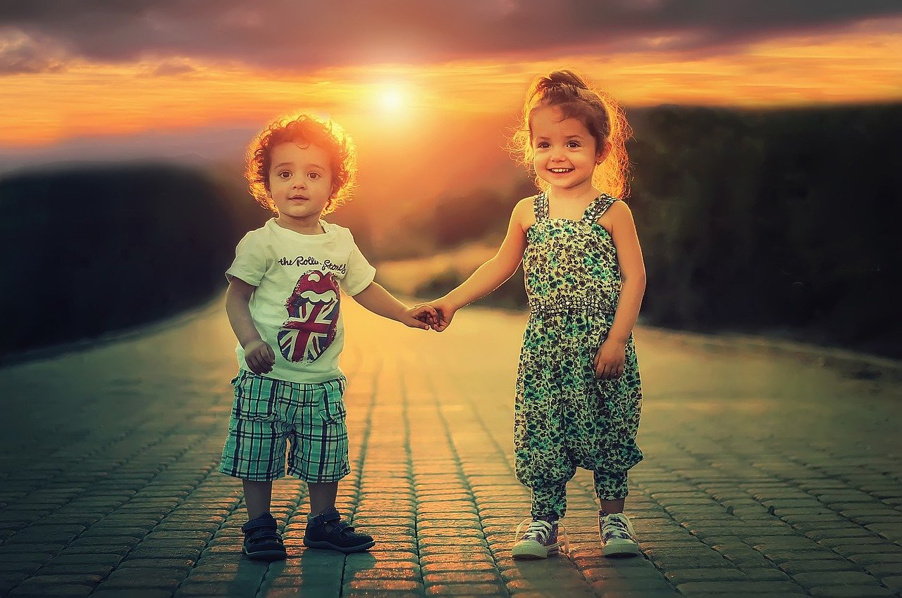
I love Brother.
I love _______.
I love ________.
Mommy
Daddy
I
love

